Name: Jing Ma

Tuesday Lab

#include "library.h"

//Part 1: Calculation

/*

const double g = 32.174; // g is gravity ft/s

void calculation( double const v, double const t){

// v = velocity

// t = time

double tt = 2*v/g;

int const h = v*t - g*(t*t)/2;

if(t<= tt){

print(h);

}

}

void main(){

print(" The hieght equals ");

calculation(200,2);

print(" feet.");

}

*/

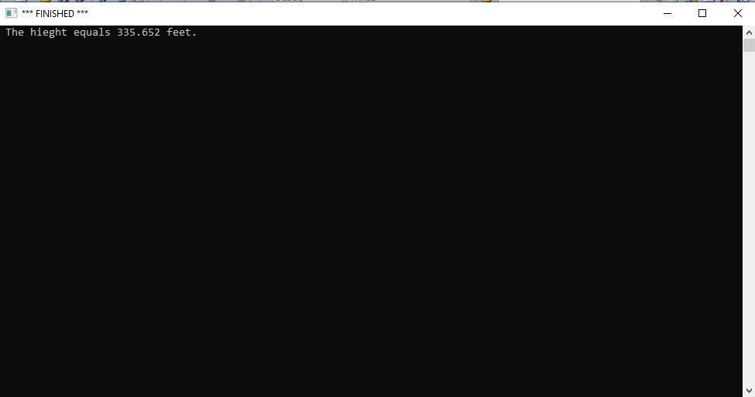

//Part 2 Tablulation

/*

const double g = 32.174;

// g is gravity ft/s

void tabulation(double const v,double const t){

const double tt = 2*v/g;

const int h = v*t - g*(t*t)/2;

if(t<= tt){

print("after ");

print(t);

print(" seconds, height is ");

print(h);

print(" feet");

new_line();

tabulation(v, t+0.5);

}

}

void tabulationLoop(int v, int t){

tabulation(v, 0);

}

void main(){

tabulationLoop(200, 12);

}

*/

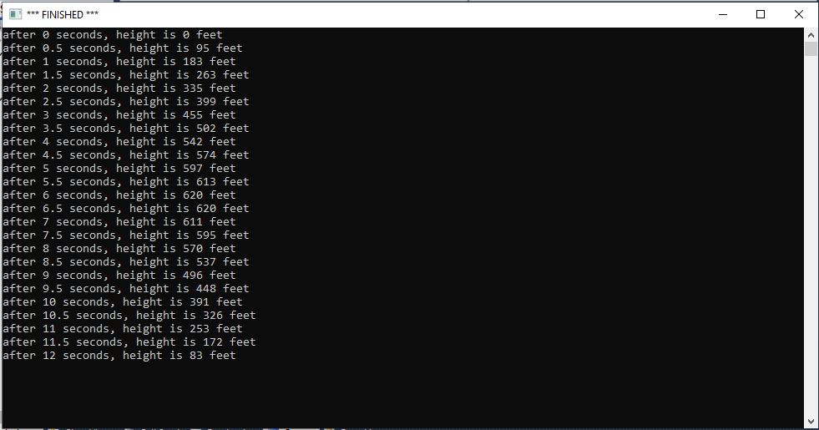

//Part 3: Interaction

/*

const double g = 32.174;

// g is gravity ft/s

void tabulation(double v, double t){

double tt = 2*v/g;

int h = ((v*t) - (0.5*g*(t*t)));

if(t<= tt){

print("after ");

print(t);

print(" seconds, height is ");

print(h);

print(" feet");

new_line();

tabulation(v, t+0.5);

}

}

void tabulationLoop(int v){

tabulation(v, 0);

}

void interaction(){

print("What is the initial velocity of the cannon ball?");

double initialVelocity = read_double();

print("The height above the ground for each time are ");

new_line();

tabulationLoop(initialVelocity);

}

void main(){

interaction();

}

*/

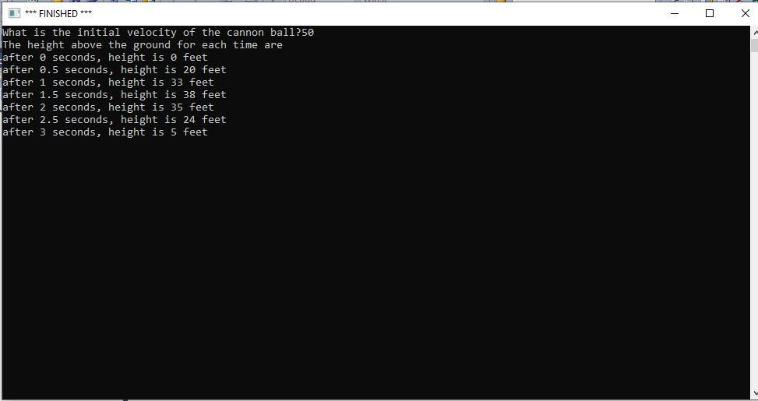

//Part 4: Visual Representation

/*

const double g = 32.174;

const double pi = acos(-1.0);

void line(int n, int s, int angle){

if(n>0){

draw_distance(s);

turn_right_by_degrees(angle);

line(n-1,s,angle);

}

}

void circle(double x, double y, double radius, double R, double G, double B){

const double pi = acos(-1.0);

double Circumference= 2*radius*pi;

double side = Circumference/360;

//move_to(x,y);

move_to(x,y-radius);

line(360,side,1);

//line(360, (2*pi*radius)/360, 1);

}

void dot(double const x, double const y, double const R, double const G, double const B){

start_shape();

circle(x,y,1,R,G,B);

set_pen_width(10);

set_pen_color(R,G,B);

fill_shape();

}

void tab_up(double const v, double const t, double const R, double const G, double const B){

double const g = 32.174;

double tt = 2*v/g;

int h = v*t - g*(t*t)/2;

if(t<= tt/2){

dot(100,600-h,R,G,B);

tab_up(v,t+1,R-0.1,G,B+0.1);

}

}

void tab_down(double v, double t, double R, double G, double B){

double const g = 32.174;

double tt = 2*v/g;

int h = v*t - g*(t*t)/2;

if(tt/2 < t <= tt){

dot(100,600-h,R,G,B);

tab_down(v,t+1,R+0.1,G,B-0.1);

}

}

void visual_rep(int initialVelocity){

make_window(200,600);

tab_up(initialVelocity,0,1.0,0.0,0.0);

tab_down(initialVelocity,initialVelocity/32.174,0.0,0.0,1.0);

}

void interaction(){

print("What is the initial velocity of the cannon ball?");

double initialVelocity = read_double();

new_line();

visual_rep(initialVelocity);

}

void main(){

interaction();

}

*/

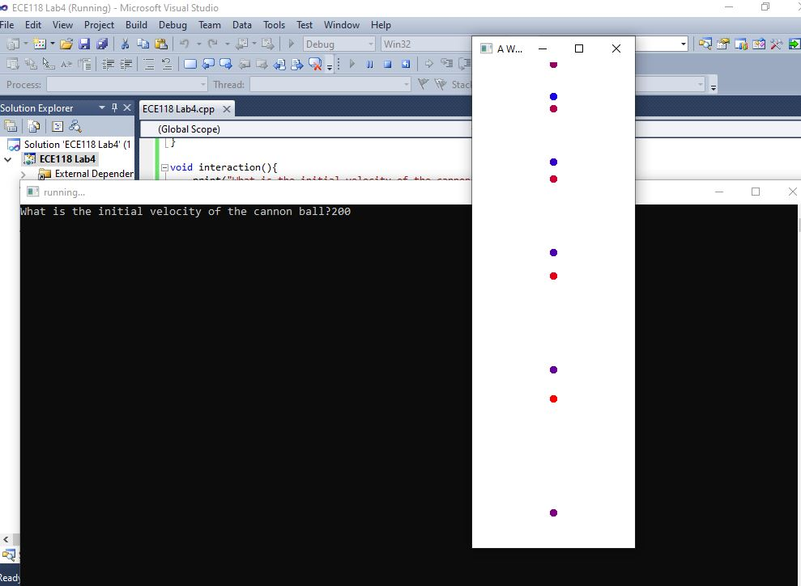

//Part 5: First Flight

/*

const double g = 32.174;

void line(int const n, int const s, int const angle) {

if(n>0) {

draw_distance(s);

turn_right_by_degrees(angle);

line(n-1,s,angle);

}

}

void circle(double const x, double const y, double const radius, double const R, double const G, double const B){

double const C = 2*radius*3.14;

double const s = C/360;

move_to(x,y-radius);

line(360,s,1);

}

void dot(double const x, double const y, double const R, double const G, double const B){

start_shape();

circle(x,y,1,R,G,B);

set_pen_width(10);

set_pen_color(R,G,B);

fill_shape();

}

void up_down(double velocity_y, double velocity_x, double y,double t, double R, double G, double B){

double const tt = 2*velocity_y/g;

int const h = velocity_y*t-g*t*t/2;

int const I = velocity_x*t;

if(t<=tt){

dot(I,y-h,R,0,B);

up_down(velocity_y,velocity_x,y,t+1,R-0.06,G,B+0.06);

}

}

void arc(double v, double degree, double x, double y, double R,double G, double B){

double const pi = acos(-1.0);

double const d = degree*pi/180.00;

double const vx = v*cos(d);

double const vy = v*sin(d);

make_window(x,y);

up_down(vy,vx,y,0,R,G,B);

}

void interaction(){

print("What is the initial velocity of the cannon ball?");

double initialVelocity = read_double();

new_line();

arc(initialVelocity,60,1000,500,1.0,0.0,0.0);

}

void main(){

interaction();

}

*/

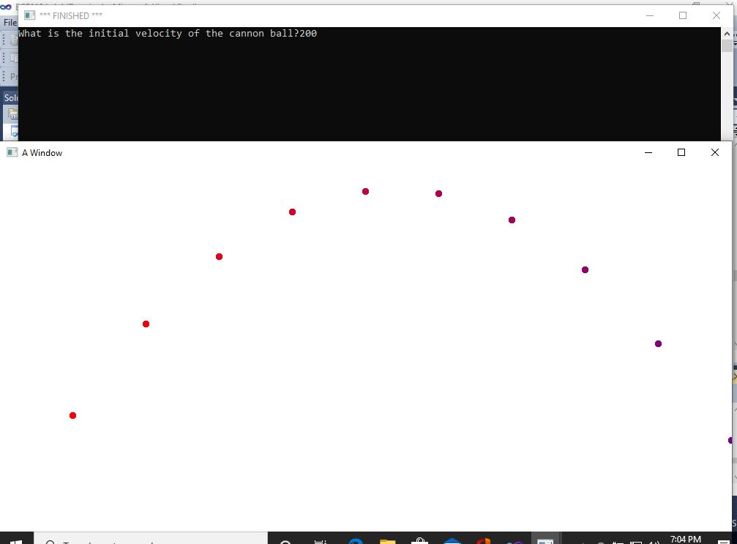

// Part 6: Nice Arc

/*

void line(int const n, int const s, int const angle) {

if(n>0) {

draw_distance(s);

turn_right_by_degrees(angle);

line(n-1,s,angle);

}

}

void circle(double const x, double const y, double const radius, double const R, double const G, double const B){

double const pi = acos(-1.0);

double const C = 2*radius*pi;

double const s = C/360;

move_to(x,y-radius);

line(360,s,1);

}

void dot(double const x, double const y, double const R, double const G, double const B){

start_shape();

circle(x,y,1,R,G,B);

set_pen_width(30);

set_pen_color(R,G,B);

fill_shape();

}

void curve(double const vy, double const vx, double const y,double const t, double const R, double const B){

double const g = 32.174;

double const tt = 2*vy/g;

double const h = vy*t-g*t*t/2;

double const I = vx*t;

if(t<=tt){

move_to(I,y-h);

dot(I,y-h,R,0,B);

curve(vy,vx,y,t+0.08,R-0.01,B+0.015);

}

}

void niceArc(double const v, double const degree, double const x, double const y, double const a, double const c){

double const pi = acos(-1.0);

double const d = degree*pi/180.00;

double const vx = v*cos(d);

double const vy = v*sin(d);

make_window(x,y);

curve(vy,vx,y,0,a,c);

}

void interaction(){

print("What is the initial velocity of the cannon ball?");

double initialVelocity = read_double();

new_line();

niceArc(initialVelocity,55,1000,600,1.0,0.0);

}

void main() {

interaction();

}

*/

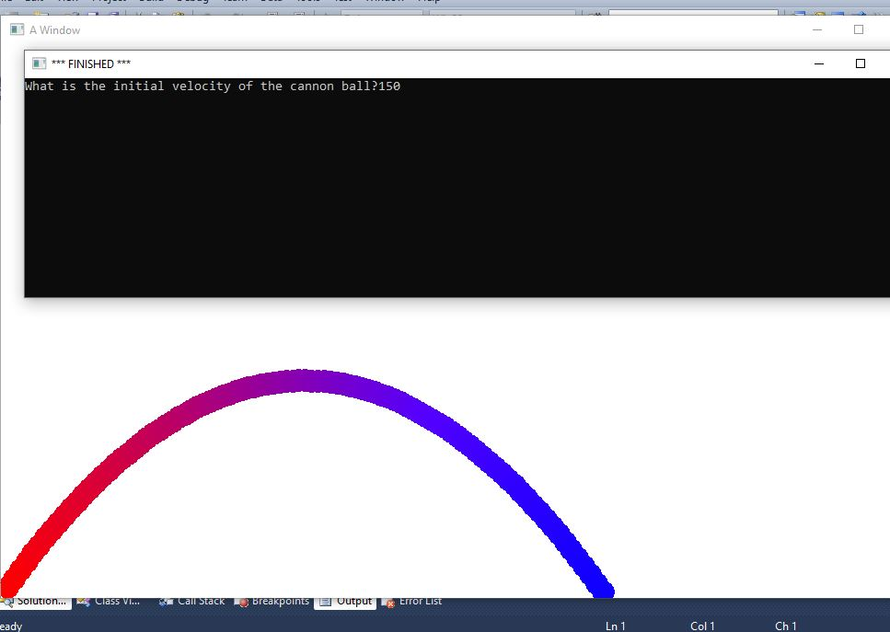

//Part 7: Take the Battle to the Enemy

/*

void line(int const n, int const s, int const angle) {

if(n>0) {

draw_distance(s);

turn_right_by_degrees(angle);

line(n-1,s,angle);

}

}

void circle(double const x, double const y, double const radius, double const R, double const G, double const B){

double const pi = acos(-1.0);

double const C = 2*radius*pi;

double const s = C/360;

move_to(x,y-radius);

line(360,s,1);

}

void dot(double const x, double const y, double const R, double const G, double const B){

start_shape();

circle(x,y,1,R,G,B);

set_pen_width(30);

set_pen_color(R,G,B);

fill_shape();

}

void up_down(double velocity_y, double velocity_x, double y,double t, double R, double G, double B){

double const g = 32.174;

double const T = 2*velocity_y/g;

int const h = velocity_y*t-g*t*t/2;

int const I = velocity_x*t;

if(t<=T){

dot(I,y-h,R,0,B);

up_down(velocity_y,velocity_x,y,t+1,R-0.06,G,B+0.06);

}

}

void curve(double const vy, double const vx, double const y,double const t, double const R, double const B){

double const g = 32.174;

double const tt = 2*vy/g;

double const h = vy*t-g*t*t/2;

double const I = vx*t;

if(t<=tt){

move_to(I,y-h);

dot(I,y-h,R,0,B);

curve(vy,vx,y,t+0.08,R-0.01,B+0.015);

}

}

void arc(double v, double degree, double x, double y, double R,double G, double B){

double const pi = acos(-1.0);

double const d = degree*pi/180.00;

double const vx = v*cos(d);

double const vy = v*sin(d);

make_window(x,y);

up_down(vy,vx,y,0,R,G,B);

}

void niceArc(double const v, double const degree, double const x, double const y, double const a, double const c){

double const pi = acos(-1.0);

double const d = degree*pi/180.00;

double const vx = v*cos(d);

double const vy = v*sin(d);

make_window(x,y);

curve(vy,vx,y,0,a,c);

}

void battle(){

print("What is the initial velocity of the cannon ball?");

double initialVelocity = read_double();

new_line();

print("What is the initial degree?");

double degree = read_double();

new_line();

double const pi = acos(-1.0);

double const d = degree*pi/180.00;

double const vx = initialVelocity*cos(d);

double const vy = initialVelocity*sin(d);

double const g = 32.174;

double const tt = 2*vy/g;

niceArc(initialVelocity,degree,1000,600,1.0,0.0);

new_line();

print("Final horizontal distance is ");

print(vx*tt);

print(" feet");

}

void main() {

battle();

}

*/

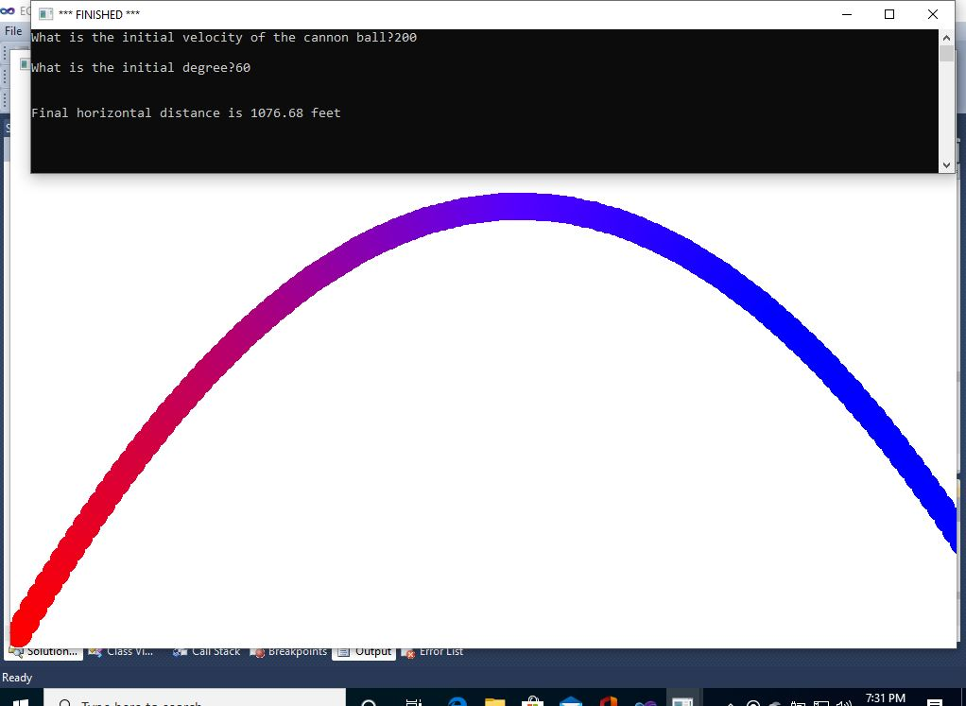

// Part 8: The Game (not completed)

void line(int const n, int const s, int const angle) {

if(n>0) {

draw_distance(s);

turn_right_by_degrees(angle);

line(n-1,s,angle);

}

}

void circle(double const x, double const y, double const radius, double const R, double const G, double const B){

double const pi = acos(-1.0);

double const C = 2*radius*pi;

double const s = C/360;

move_to(x,y-radius);

line(360,s,1);

}

void dot(double const x, double const y, double const R, double const G, double const B){

start_shape();

circle(x,y,1,R,G,B);

set_pen_width(30);

set_pen_color(R,G,B);

fill_shape();

}

void up_down(double velocity_y, double velocity_x, double y,double t, double R, double G, double B){

double const g = 32.174;

double const T = 2*velocity_y/g;

int const h = velocity_y*t-g*t*t/2;

int const I = velocity_x*t;

if(t<=T){

dot(I,y-h,R,0,B);

up_down(velocity_y,velocity_x,y,t+1,R-0.06,G,B+0.06);

}

}

void curve(double const vy, double const vx, double const y,double const t, double const R, double const B){

double const g = 32.174;

double const tt = 2*vy/g;

double const h = vy*t-g*t*t/2;

double const I = vx*t;

if(t<=tt){

move_to(I,y-h);

dot(I,y-h,R,0,B);

curve(vy,vx,y,t+0.08,R-0.01,B+0.015);

}

}

void arc(double v, double degree, double x, double y, double R,double G, double B){

double const pi = acos(-1.0);

double const d = degree*pi/180.00;

double const vx = v*cos(d);

double const vy = v*sin(d);

make_window(x,y);

up_down(vy,vx,y,0,R,G,B);

}

void niceArc(double const v, double const degree, double const x, double const y, double const a, double const c){

double const pi = acos(-1.0);

double const d = degree*pi/180.00;

double const vx = v*cos(d);

double const vy = v*sin(d);

make_window(x,y);

curve(vy,vx,y,0,a,c);

}

void battle(){

print("What is the initial velocity of the cannon ball?");

double initialVelocity = read_double();

new_line();

print("What is the initial degree?");

double degree = read_double();

new_line();

double const pi = acos(-1.0);

double const d = degree*pi/180.00;

double const vx = initialVelocity*cos(d);

double const vy = initialVelocity*sin(d);

double const g = 32.174;

double const tt = 2*vy/g;

niceArc(initialVelocity,degree,1000,600,1.0,0.0);

new_line();

print("Final horizontal distance is ");

print(vx*tt);

print(" feet");

}

void draw_cannon(double const x, double const y, double const radius){

double const pi = acos(-1.0);

set_pen_color(color::black);

set_pen_width(10);

start_shape();

move_to(x,y); note_position();

turn_right_by_radians(1.571);

turn_left_by_radians(0.1);

draw_distance(4*radius); note_position();

turn_left_by_radians(1.483);

draw_distance(2*radius); note_position();

turn_left_by_radians(1.483);

draw_distance(6*radius); note_position();

turn_left_by_radians(1.657);

draw_distance(2*radius+6*2*radius*cos(1.483)); note_position();

turn_left_by_radians(1.657);

draw_distance(2*radius); note_position();

turn_left_by_radians(pi);

draw_distance(radius); note_position();

turn_right_by_radians(pi);

}

void shooting(double const x, double const y, double const angle){

double const pi = acos(-1.0);

turn_left_by_radians(angle*pi/180.00);

draw_cannon(x,y-10,10);

turn_right_by_radians((angle+5)*pi/180.00);

turn_left_by_radians(pi/2);

circle(x,y-10,10,0.0,0.0,0.0);

set_pen_color(color::white);

fill_shape();

turn_left_by_radians(1.5708);

circle(x,y-10,10,0.0,0.0,0.0);

turn_left_by_radians(pi/2);

}

void battle(){

print("What is the initial velocity of the cannon ball?");

double initialVelocity = read_double();

new_line();

print("What is the initial degree?");

double degree = read_double();

new_line();

double const pi = acos(-1.0);

double const d = degree*pi/180.00;

double const vx = initialVelocity*cos(d);

double const vy = initialVelocity*sin(d);

double const g = 32.174;

double const tt = 2*vy/g;

make_window(800,400);

shooting(40,400,35);

niceArc(initialVelocity,degree,800,400,1.0,0.0);

new_line();

print("Final horizontal distance is ");

print(vx*tt);

print(" feet");

}

void main(){

battle();

}

//Part 9: Make it Interesting